**WEEK 7 and 8 output documentation**



**Documentation**

Fundamentals of Data Science

UFCFK1-15-0

**Submitted by:**

**Name:** Shrawan Budhathoki

**Section:** I

**Student ID:** 25024656

**Github url:**

**https://github.com/kopiko2910/FODs-tasks.git**

**Question 1**

This program imports NumPy and generates array with the help of it. Sum of arrays and average elements are printed at the end.

**Input and output**

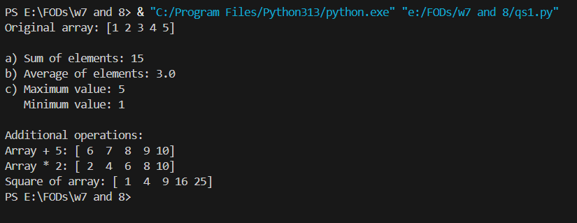

**Question 2**

This program takes a list of arrays and is sorted out accordingly. Furthermore, slicing is also done based on the requirements.

**Input and output**

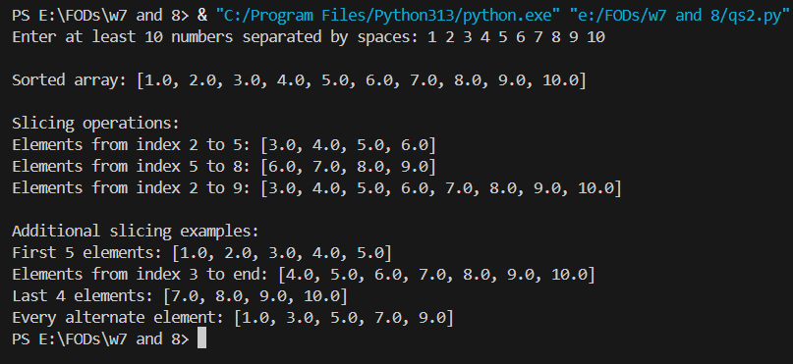

**Question 3**

This program takes matrices of 2 dimensions using NumPy and they are sorted and reshaped accordingly.

**Input and output**

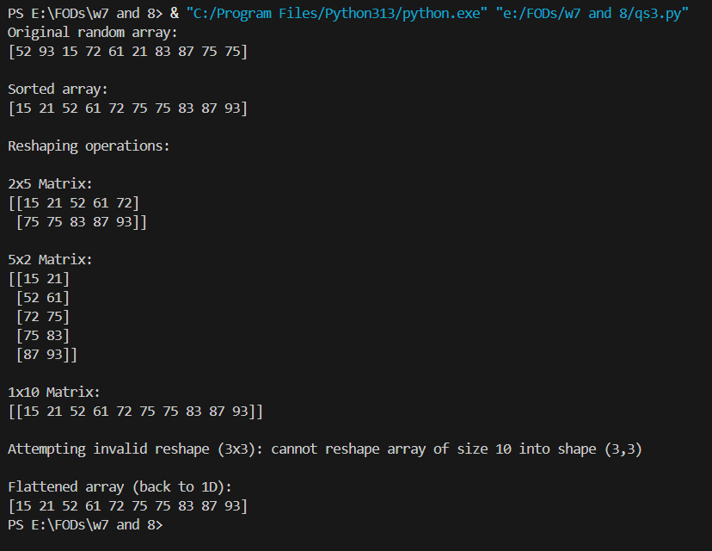

**Question 4**

This program takes 2 matrices and performs calculation such as addition, subtraction using NumPy. Mismatch of matrices raises and exception:

**Input and output**

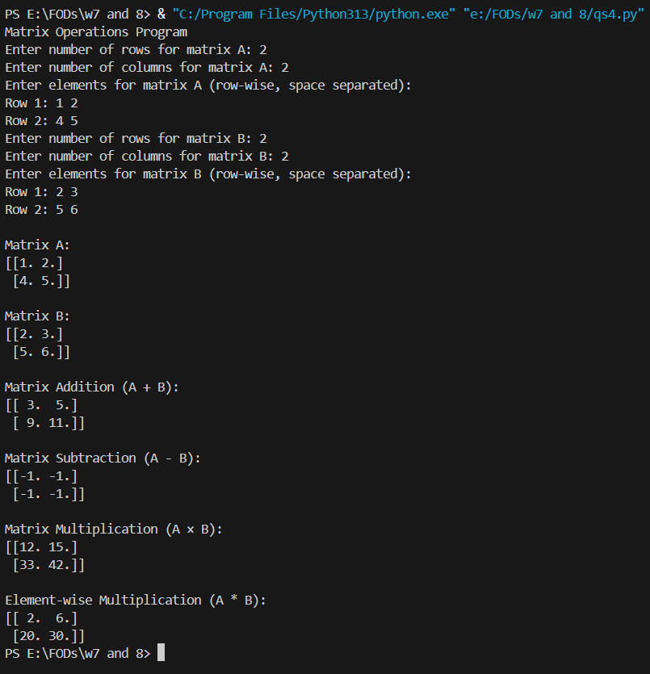

**Question 5**

This program reads the height_weight.csv file and using panda, the data is plotted using Matplotlib library

**Input and output**

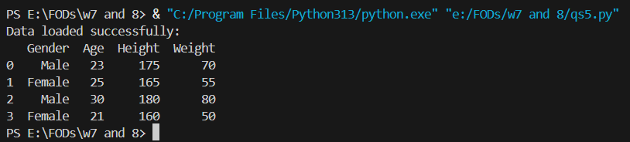

**Graph**

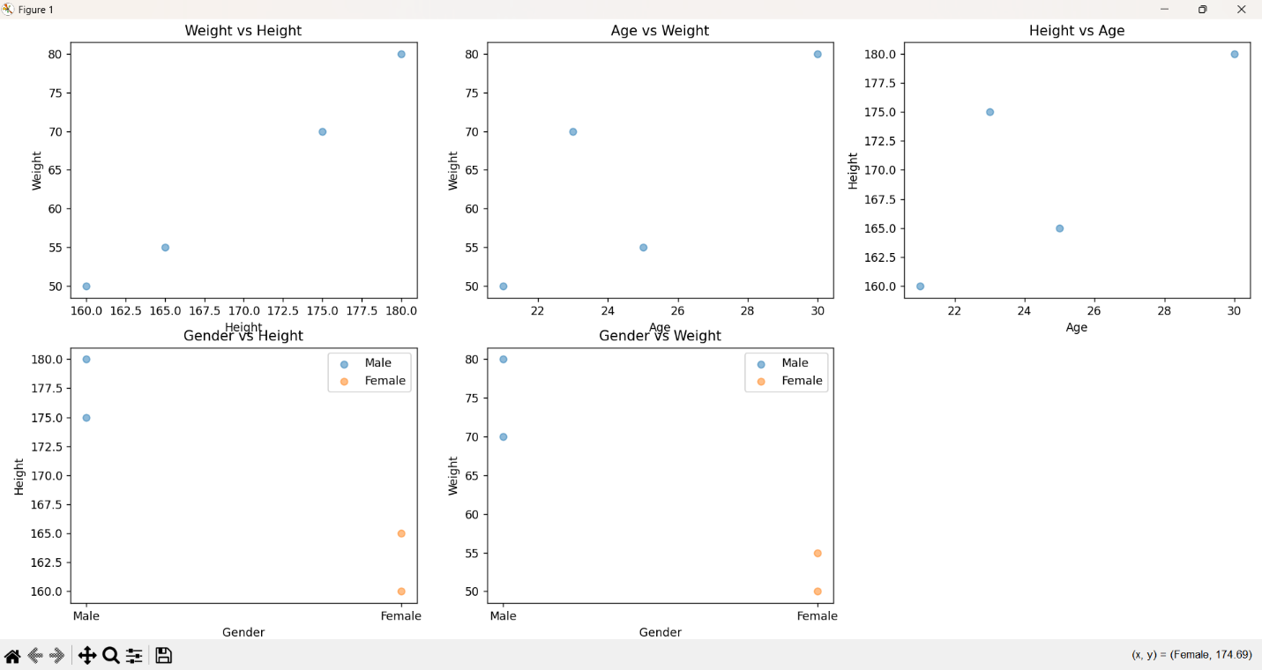

**Question 6**

This program also reads data from a csv file. Using panda, the data is printed in a graph.

**Input and output**

